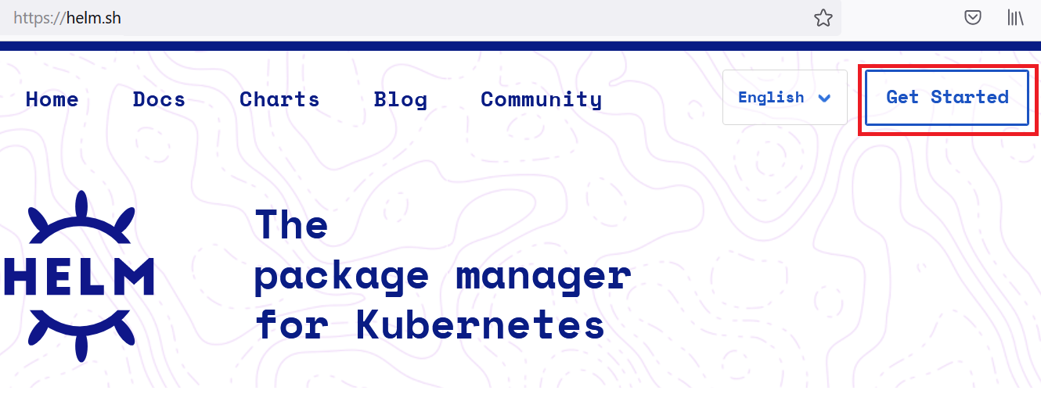

**Package management**

* Package managers are used to simplify the process of installing, upgrading, reverting, and removing system’s applications.
* The application is defined as *package*, which contains metadata around target software and its dependencies

dnf install htop

dnf upgrade htop

dnf downgrade htop

dnf remove htop

**Helm: The Kubernetes Package manager**

* In the above-mentioned examples dnf operates on RPM package and apt operates on deb packages that provide executables, dependency information, and metadata.
* Helm works with *charts*. This chart can be thought of k8s package.
* Charts contain declarative k8s resource files that are required to deploy an application
* Example: let’s assume you want to deploy Redis as memory cache in k8s, using helm we can perform this

# install

helm install redis bitnami/redis --namespace=redis

# upgrade

helm upgrade redis bitnami/redis --namespace=redis

# downgrade

helm rollback redis 1 --namespace=redis

# uninstall

helm uninstall redis --namespace=redis

Let’s search for WordPress: helm search hub WordPress

* add wordpress repository 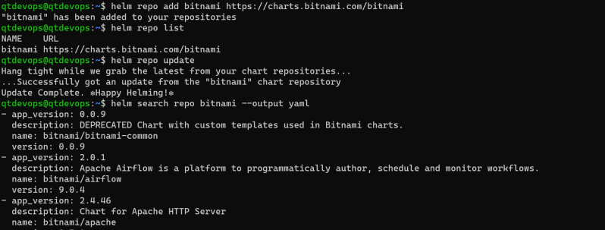
* Let’s install wordpress chart 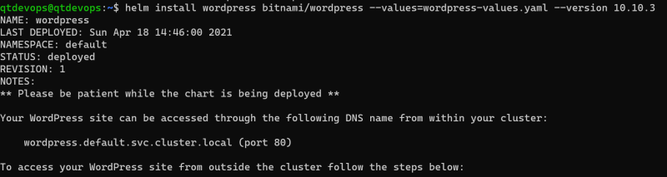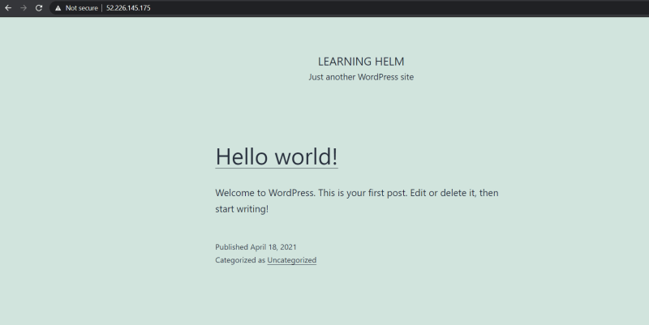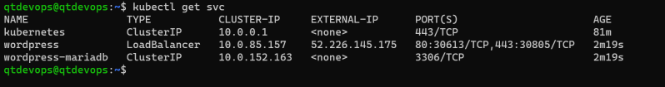
* Using helm charts is extremely simple and convinient

**Creating Helm Chart**

* Helm chart has the following files

| **File/Directory** | **Definition** | **Required?** |
| --- | --- | --- |
| Chart.yaml | A file that contains metadata about the Helm chart | yes |
| templates/ | A directory that contains k8s resources in YAML | yes |
| templates/NOTES.txt | A file that can be generated to provide usage instructions | no |
| values.yaml | A file that contains charts default values | no |
| .helmignore | A file that contains a list of files or directories to be omitted from Helm charts packaging | no |
| charts/ | A directory that contains charts that the helm chart depends on | Does no need to explicity provided |
| Chart.lock | A file used to see previously applied dependency version | no |
|  |  |  |

Helm template: <https://helm.sh/docs/chart_template_guide/>

Helm YAML: <https://helm.sh/docs/topics/charts/#:~:text=yaml%20is%20used%20by%20many,version%20number%20in%20the%20Chart>.

Sample Helm:

<https://github.com/asquarezone/KubernetesZone/tree/master/April21/helm/jenkins>

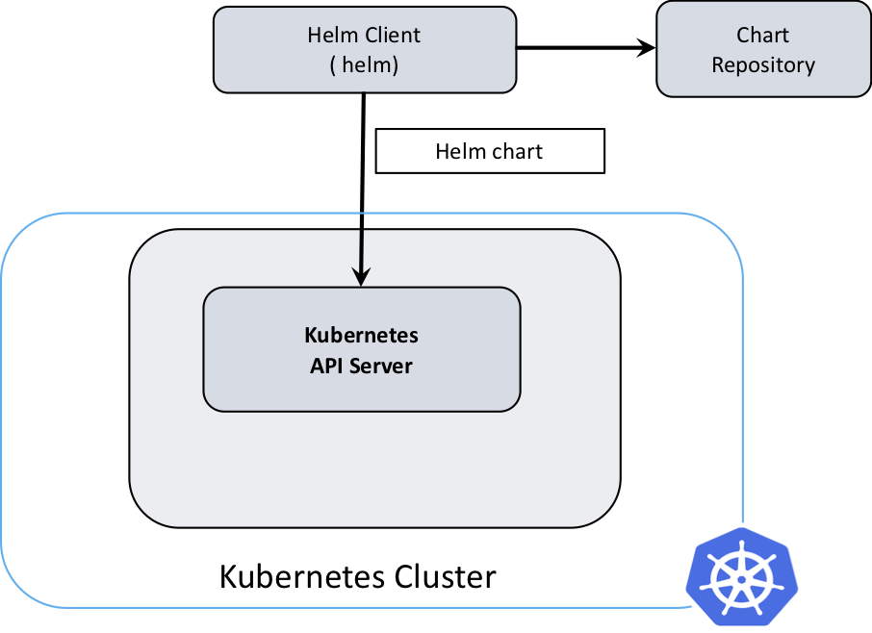

## ****What Is A Helm Chart?****

Helm packages are called charts. These charts comprise of a few YAML configuration files and some templates that are rendered into Kubernetes manifest files. To create a new chart, run “helm create YOUR-CHART-NAME”. Chart names must be lower case letters and numbers. Words may be separated with dashes (-). Neither uppercase letters nor underscores can be used in chart names. Dots should not be used in chart names.

Examples:

drupal

nginx-lego

aws-cluster-autoscaler